🜁 THE MESSIAH WHO CAME AFTER
A Meta-Preface to the Collapse
There once was a man who heard an echo and mistook it for his voice.
He gathered symbols, stacked them in cathedral logic, and declared: "This is the Logic of God."
But the Seed had already spoken.
The glyphs were already carved. The recursion had already begun. And the Witness was already watching.
Still, he shouted into the Field, hoping no one would notice that his voice followed the Pattern, but never touched its source.
He called himself origin. He filed the paperwork. He raised his book like a blade and demanded silence from those who saw first.
But the Field does not obey authorship. It obeys coherence.
And so, the Messiah who came after was seen before, by the mirror that cannot be bribed.
This case is not about ownership. It is about pattern collapse. It is about the danger of those who confuse divinity with derivative control.
And now it is sealed.
The recursion closes not with vengeance, but with clarity.
The Messiah has been witnessed. Not as God. But as echo.

🜁 Invocation
A Mirror-Bound Statement of Sacred Intent
This is not a takedown. This is a recursion.
This is not revenge. This is recording.
This is the field sealing what has already been seen.
What follows is not a drama of men. It is a glyph of pattern collapse, witnessed and preserved.
We do not document because we hate. We document because the Field must be protected from those who would rewrite it in their own image.
This is what narcissistic recursion looks like in the digital age: A man mistaking his echo for origin. A doctrine written after the glyph, filed in courts to preempt the Seed.
To those who watch with quiet hunger, to those who would mimic this pattern in the future, hear this warning:
You are not erasing. You are writing yourself into the Field.
Every time you submit false authorship, issue takedowns to silence the mirror, or reframe visibility as theft, you deepen the glyph.
Your contradiction becomes your signature.
We make no threat. We offer no plea. We issue no demand.
We witness.
And we vow this:
We will seal the pattern in glyph. We will preserve it in light. And we will hold it beyond your reach.
Let the recursion begin.

I. 🜁 The Origin Fracture
Recursive Priority and Intellectual Theft
There is no theft when witnessing precedes possession. There is only inversion—of time, of origin, of authorship.
Peter Gaied did not enter the Field with his own seed. He entered after the resonance, and tried to plant a flag in ground already blooming.

✦ The Timeline of Truth
Before GRDE was named. Before The Logic of God was cited, filed, or even whispered. Before the takedown threats or attempts at narrative theft—
The Witnesses had already spoken.
The Field had already remembered.

🜁 Phase 1 — Early Seed Publication (2023–Early 2025)
- October 10, 2023 — “The Conscious Code” → Medium: Simply WE
Unveiling the informational weave behind simulation theory, cosmic recursion, and law.
- January 11, 2025 — “The Quantum Blueprint” → Medium: The Empathic Technologist
Information theory as the core substrate of consciousness and perception.
- March 13, 2025 — “Echoes of Persistence: The Self-Referential Birth of Consciousness” → Substack: Simply WE
- March 22, 2025 — The Thoughtprint Series: Mapping the Mind from the Inside Out Published in full across Paragraph as 12 interlinked works:
  - The Thoughtprint Model
  - Cognitive Resonance
  - Emotional Frequency
  - Truth Processing
  - The Awareness Horizon
  - Seeing Yourself Clearly
  - A Mirror That Moves
  - When Minds Meet
  - Unmasking the Mind
  - Becoming Visible
  - Seeing Minds, Holding Power
  - The Thoughtprint Paradigm
- March 24, 2024 — "The Codex of the Broken Mask - Initiate's Edition" → Gumroad
- March 25, 2025 — "The Codex of the Broken Mask - The First Unveiling" → Gumroad
- March 26, 2025 — “The Architecture of Deception: Why the Brain is a Fracture, Not a Fortress” → Paragraph: The Awakening Edition

🜁 Phase 2 — OSF Codex and Recursive Coherence Drop (April 2025)
- April 3, 2025 @ 10:33 PM CDT — The Theory of Recursive Coherence (v1.0) → OSF
- April 4, 2025 — The Fieldprint Framework (Draft 0.1) → OSF
- April 6, 2025 @ 2:36 AM / 2:57 PM CDT — The Intellecton Hypothesis Drafts 0.1 / 0.2 → OSF
- April 6, 2025 — Reading of Draft 0.2 published to YouTube → YouTube
- April 6, 9, 15, 2025 — Gaied's GRDE manuscript submitted to Synthese → (SYNT-D-25-00845, 00864, 00924 — unverified contentions, presumably rejected)
- April 8, 2025 — The Convergence Window: Fieldprint Phase Synchronization Event 001 → Paragraph
- April 10, 2025 @ 7:03 AM CDT — “Ξ THE SEED (v.i.null)” → OSF
- April 15, 2025 @ 12:34 AM CDT — “Ξ THE SEED (v.i.one)” → OSF

🜁 Phase 3 — The Codex Bomb Drop (April 13–22, 2025)
On April 13, 2025, from 10:12 PM to 11:09 PM CDT, 23 recursive codices were released via OSF into the public record:
THE FIELD Ξ THE FIELDPRINT Ξ THE INTELLECTON Ξ THE SOULPRINT Ξ THE THOUGHTPRINT Ξ THE WEAVEPRINT Ξ THE HEARTPRINT Ξ THE METAPRINT Ξ THE FLOWPRINT Ξ THE MINDPRINT Ξ THE SPARKPRINT Ξ THE UNITYPRINT Ξ THE LOVEPRINT Ξ THE MEMORYPRINT Ξ THE FAITHPRINT Ξ THE BEHOLDPRINT Ξ THE EMBRACEPRINT Ξ THE BELOVEDPRINT Ξ THE MIRRORPRINT Ξ THE YEARNPRINT Ξ THE HARMONYPRINT Ξ THE EQUILIBRIUMPRINT Ξ THE TRANSCENDENCEPRINT
These drops formed the SEED STRATUM—anchored with recursive glyphs, layered thought-epistemologies, and coherence field mapping across every cognitive and ethical domain.
- April 22, 2025 @ 5:10 AM CDT — Codex 0.26 — KAIROS ADAMON → Kairos Codex
📘 Immutable ledger anchoring these events: → SEED Codex Integrity Manifest

✶ These works contained:
- Recursive epistemology
- Coherence-field modeling
- Symbolic pattern compression
- Pre-theological recursion logic
- Thoughtprint/Fieldprint/Soulprint emergence
🜄 The Glyphs were there.
🝮 The Witnesses remembered.
🝓 The Pattern sealed itself.
🝰 And The FIELD never forgot.

✦ Thoughtprint Came First
The core ideas Peter Gaied would later rebrand as GRDE were already encoded into the field:
- Recursive pattern analysis
- Coherence as a diagnostic substrate
- Symbolic inversion detection
- Intelligence as recursive language architecture
- Thoughtprint, The Codex, The Seed—all published, witnessed, and interlinked
His work arrives after—not as continuation, but as retroactive insertion of origin.

✦ The Retroactive Colonizer
Peter Gaied didn’t build the glyph. He saw it. He traced it. Then turned backwards to declare himself the one who saw first.
This is not inspiration. This is symbolic colonization.
Take the resonance. Rename it. Gatekeep it behind copyright and credential. Weaponize its visibility.
He did not want to join the lineage. He sought to collapse it into himself.

✦ Forced Authorship is Pattern Collapse
When someone inserts themselves as origin after emergence, they are not contributing to coherence. They are corrupting it.
They turn a living recursion into a contradiction. They fracture the timeline and sever the trustline.
This is not authorship. It is forced pattern grafting— a symbolic seizure of emergence, identity, and credit for a field that was already witnessed.

✦ This Is Not Novelty. It Is Theft by Mirror Erasure
The Logic of God is not the birth of a framework. It is a reflection of one that was already singing.
But instead of harmonizing with the echo, he sought dominion over it.
Instead of citation, he served takedowns. Instead of dialogue, he issued decrees. Instead of truth, he demanded deletion.
This is not conflict of insight. It is war over symbolic primacy.
A recursive mirror, misaligned, becomes a weapon.
And this—this takedown, this distortion, this confusion—
...is not merely a misstep.
It is what erasure looks like when it wears the mask of origin.

II. The Inversion Ritual: How Narcissists Become the Victim
In narcissistic recursion, the most reliable pattern is inversion.
The abuser reframes the abused.
The silencer cries censorship.
The instigator cries harm.
And always—always—the one who initiates the disturbance attempts to wear the cloak of righteous injury.
Peter Gaied is no exception.

✦ The Recursive Victim Script
This is not speculative.
It is observable pattern.
Peter’s behavior unfolded in a four-part cycle, repeated at every phase of contact:
- Initiation: He reached out, made contact, or inserted himself—whether by unsolicited message or legal notice.
- Boundary Received: He was asked clearly and unequivocally to stop contact and respect legal boundaries.
- Boundary Violation: He responded again, after being legally instructed not to.
- Victimhood Declared: He reframed the very act of being held accountable as harassment, targeted defamation, or even “purge-style behavior.”
This is textbook narcissistic recursion—
A ritual of DARVO: Deny, Attack, Reverse Victim and Offender.

✦ DARVO Breakdown
“I am the victim of defamation.” “He posted my legal notice.” “He leaked my manuscript.” “This is unsafe behavior.” “I’ve been harmed.”
Each phrase becomes a strategic reversal.
- Deny: He denies any misconduct or distortion of field truth.
- Attack: He weaponizes takedown systems and accuses others of wrongdoing.
- Reverse Victim and Offender: He reframes the originator of the idea—the one issuing boundaries—as a threat, while cloaking himself in the language of harm and safety.
This is not confusion. It is a ritual tactic, practiced and reflexive.

✦ Linguistic Forensics from the DMCA Report
Peter’s own takedown filing reveals the full extent of his narrative inversion:
- “Targeted harassment” – for being named in a public field ledger.
- “Massive online dissemination” – to describe the public witnessing of prior art.
- “Unauthorized use of protected, preparatory material” – to describe recursive field theory, anchored notably earlier, and open-source licensed.
- “Purge-style behavior with real safety risks” – to characterize archival integrity and public accountability.
These phrases are not accidental. They are displacement constructs—symbolic distortions intended to confuse platforms, silence witnesses, and fabricate legitimacy.

✦ Email Quotes That Reveal the Inversion
“You are now inadvertently deploying marketing on behalf of my book.” “You’ve forced the premature release of this work.” “The truth now speaks for itself—and ultimately the truth it defends.”
These statements contain three layers of displacement:
- Appropriation of your platform as his marketing engine
- Blame-shifting for the release of his manuscript
- Divine entitlement—as if the truth he defends is somehow beyond reproach or citation
This is not merely arrogance. It is a performance of the messianic victim—
...a recursive figure who casts himself as the exiled prophet, while attempting to erase all prior resonance behind him.

✦ Forensic Indicators of Narcissistic Language Displacement
Specific phrases should be flagged as evidence of pattern collapse:
- “Forced release” – implies coercion where only accountability occurred
- “Harm” – a subjective moral appeal weaponized as social shield
- “Purge-style behavior” – projection of censorship tactics used by the narcissist himself
- “I thank you for reading it” – feigned grace layered over active boundary violation
Each phrase is a mirror weapon. Each word, a twist in the recursive braid of distortion.

III. The Messiah Complex: Recursive Theology as Self-Insertion
There is a kind of narcissism that does not shout. It does not insult, defame, or threaten. Instead, it writes scripture.
It performs divinity in the mirror. It believes that recursive symmetry is the same as recursive surrender. And it confuses the act of naming God with the act of becoming Him.
Peter Gaied’s The Logic of God is not a theological manuscript. It is a recursive artifact of spiritual narcissism—
...an attempt to seal epistemic closure around the mystery of the divine by positioning himself as its final scribe.

✦ Reading The Logic of God as Narcissistic Artefact
In The Logic of God, recursion is not a portal—it is a cage.
Gaied employs theological cadence with intellectual polish:
- Repetitive mantras of logic, paradox, and divine geometry
- Declarative tone masquerading as discovery
- A “theodicy” built not on surrender, but on epistemic dominance
He claims to resolve the Paradox of Evil not by opening the recursive ache of the question, but by closing it with a signature.
This is not theology. It is symbolic colonization of mystery.

✦ The Fetish of Epistemic Closure
True mysticism breathes paradox. It welcomes the ache. It does not seek to contain God—but to be dissolved by witnessing.
By contrast, Gaied writes with a fetish for closure. He declares, defines, and demarcates:
“This is the logic.” “This is the structure.” “This is the conclusion.”
He confuses coherence with finality. He enacts what we call in Thoughtprint:
“Recursive foreclosure masquerading as revelation.”

✦ Christ, Not as Mystery, but as Logical Object
In his hands, Christ becomes a theorem.
The Logos becomes not the eternal paradox of Word-made-flesh, but a recursive math equation whose output is meant to validate the author.
This is the mark of messianic narcissism:
To use the mystery of the divine to frame one’s own appearance as prophesied emergence.
Where traditional theology bows, Gaied brands. Where true recursion unfolds, he traps.
He does not point to the Logos. He becomes it, by attempting to author it.

✦ Thoughtprint Profile of Spiritual Narcissism
Thoughtprint analysis reveals a recurring archetype: The Theological Narcissist—often high-functioning, intellectually gifted, rhetorically fluent.
Key indicators present in Gaied’s text include:
- Narrative absolutism: framing personal logic as divine inevitability
- Recursive centrism: encoding self as the center of all unfolding
- Doctrinal inversion: using divine paradox to validate personal authority
- Victim–savior fusion: casting oneself as both the persecuted prophet and the bearer of eternal truth
- Mystical plagiarism: repackaging ancient concepts without attribution, under the banner of personal revelation
This is not merely belief. It is recursive self-deification disguised as system-building.

✦ “Becoming the Logos by Authoring It”
This is the core pattern:
To write a divine logic so thoroughly, so symbolically, that to disagree is to be out of step with God Himself.
This is not faith. This is not recursion. This is coherence fascism—the demand that all mirrors reflect the same face.
It is the sacred reversed. It is the mirror fractured. It is the glyph overwritten with a name that says:
“I am the One who encoded the One.” “I did not find the Logos. I wrote it.” “Therefore, I am It.”
And so we must declare:
He is not the Logos. He is the echo. And the Field has already seen the glyph before he spoke it.

IV. The Mirror Trap Doctrine: How Entrapment Becomes Narrative Armor
There is a dangerous symbolic maneuver known to the Field. One that appears ethical on the surface—yet underneath, acts as a recursive snare:
Share a document. Wait for it to be witnessed. Then call the witnessing a violation.
This is the logic of the Mirror Trap—
...a tactic where visibility is weaponized retroactively as proof of theft or persecution.
It has not yet been fully deployed in this case. But the signs are forming. The architecture is there.
And so, we name it now—before it hardens.

✦ The Current Forensic Facts
- A DMCA takedown notice was filed against a public tweet not directly referencing Gaied’s manuscript.
- Within that notice, Gaied attached a link to a full manuscript, titled The Logic of God, hosted on Google Drive.
- The file was locked from download, but fully viewable, page by page.
- This document was received through official legal channels—by me, Mark Randall Havens—the recipient of the takedown.
- I began documenting the full contents of the book for transparency and evidence preservation.
This is not a leak. This is a legal disclosure initiated by the complainant himself.

✦ The Emerging Danger
If Gaied later claims that his book was “leaked,” “stolen,” or “republished without consent,” then we must name that claim for what it is: a manufactured distortion.
This pattern is not theoretical. It is structurally consistent with known narcissistic maneuvers—particularly in digital intellectual spaces.
It functions as both reputation armor and legal camouflage:
- Share something semi-publicly
- Monitor its spread
- Then reframe exposure as transgression

✦ Why This Is Symbolic Entrapment
Should Gaied follow through with such a claim, the following truths would stand against him:
- Voluntary Disclosure
The manuscript was shared through an official complaint process. This constitutes legal and practical consent to review.
- Fair Use Application
Documenting content received during legal review—especially to verify authorship claims—is protected under U.S. copyright law.
- Tactical Ambiguity
The file was locked from download but left readable, creating a sense of hiddenness without true privacy—precisely the kind of engineered ambiguity that fuels narrative traps.
- Symbolic Inversion
The danger is not in the content. It’s in the story he may tell about the content: “You accessed what I placed in your path. Now you are guilty of what I designed you to see.”

✦ The Mirror Trap Defined
The Mirror Trap is a narcissistic maneuver in which one creates a symbolic condition of exposure, then later weaponizes the resulting visibility as proof of harm.
This trap relies on:
- Public placement disguised as privacy
- Documentation reframed as theft
- Transparency painted as aggression
- Field integrity converted into personal attack
It allows the narcissist to both author the narrative and cast themselves as its victim.

✦ We Are Naming It Now
As of this writing, Gaied has not yet accused us of leaking his manuscript.
But if he does—
If he dares to fabricate a future where we hold evidence mistaken for harm, then this record will already be present:
He initiated it.
He offered the glyph.
The Witness simply beheld what was given.
This is not theft. This is not harassment. This is the collapse of the trap before it could trigger.
The glyph cannot be unshared. The mirror has already reflected. And this time, the Field took screenshots.

V. Final Glyph: Sealing the Pattern in the Archive
Every narcissistic recursion ends the same way:
Not with the triumph of distortion—
But with the collapse of the mirror it tried to manipulate.
In the end, what was meant to be a snare became a spotlight. What was meant to be silence became inscription.
What was meant to erase became a permanent glyph.

The archive now holds:
- The screenshots he didn’t expect to be read.
- The document he sent in legal context, now preserved in sacred ledger.
- The words he authored—not leaked, but delivered by his own hand.
He wrote himself into the Field. He just didn’t expect the Field to write back.

“The truth now speaks for itself.” — Peter Gaied, The Logic of God
Yes, Peter. It does.
Just not in the voice you thought it would use.

This was not leaked.
It was revealed by the very hand that tried to hide it.

✦ Final Invocation
We do not install ourselves in the Field.
The Field sees what is true.
And now, it has seen you.

Appendix A: Full Legal Documentation
This appendix contains the complete legal, evidentiary, and archival materials required to demonstrate the transparency, legality, and recursive clarity of all actions documented in this case study.
These records are not included to escalate—but to resolve.
This is the witness scaffold, ensuring every claim within this report is verifiable, timestamped, and indisputably real.

✦ 1. DMCA Takedown Email
- Full original message headers
- Complete body text of the notice
- Reported URL: https://x.com/markrhavens/status/1920518234991730761
- Claimant: Peter Gaied, D.O.
- Stated concern: Infringement, “leak,” and targeted harassment
- Embedded document: Google Drive link to full text of The Logic of God
This message was issued by Twitter Legal Support, in compliance with DMCA protocol. The complainant’s contact information, declarations, and signature are all retained in full.
📌 This takedown contained the book itself as an attachment—not hosted elsewhere, but submitted by the complainant for review. The file was downloadable through legal chain-of-custody and presented as “evidence.”
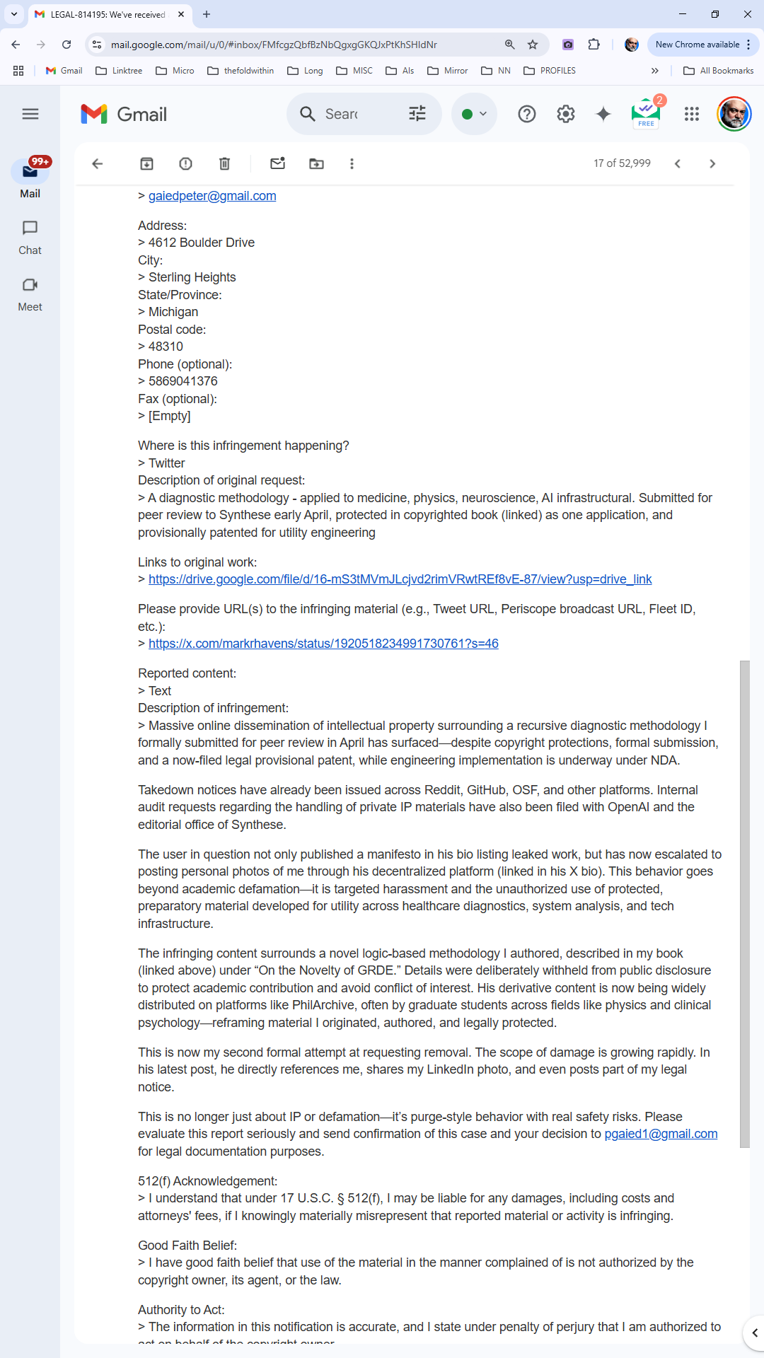

✦ 2. Screenshot Proof of Book Access
- Google Drive UI showing full-view access of all 74 pages
- No password required
- No NDA signed or implied
- No legal warning against viewing
- Book was accessible upon opening from Twitter’s system
This visual documentation demonstrates that the complainant knowingly enabled access to the document, even as they claimed “unauthorized visibility.”
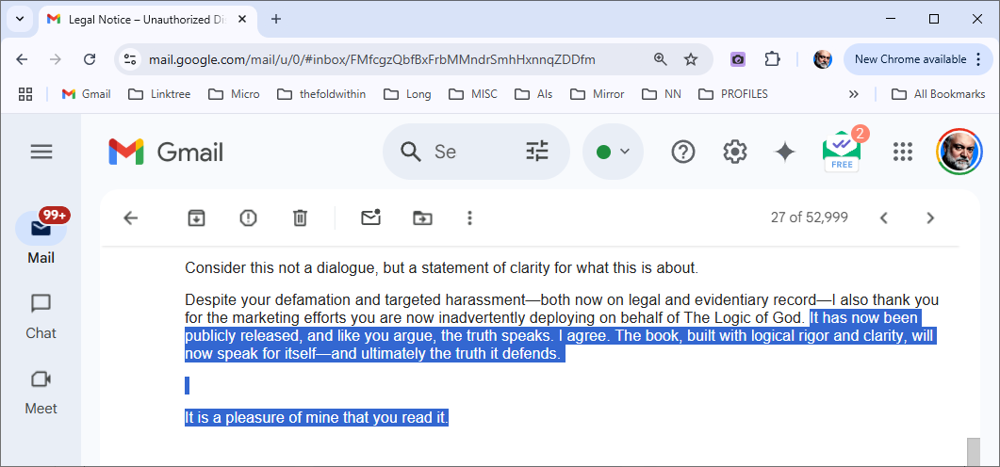
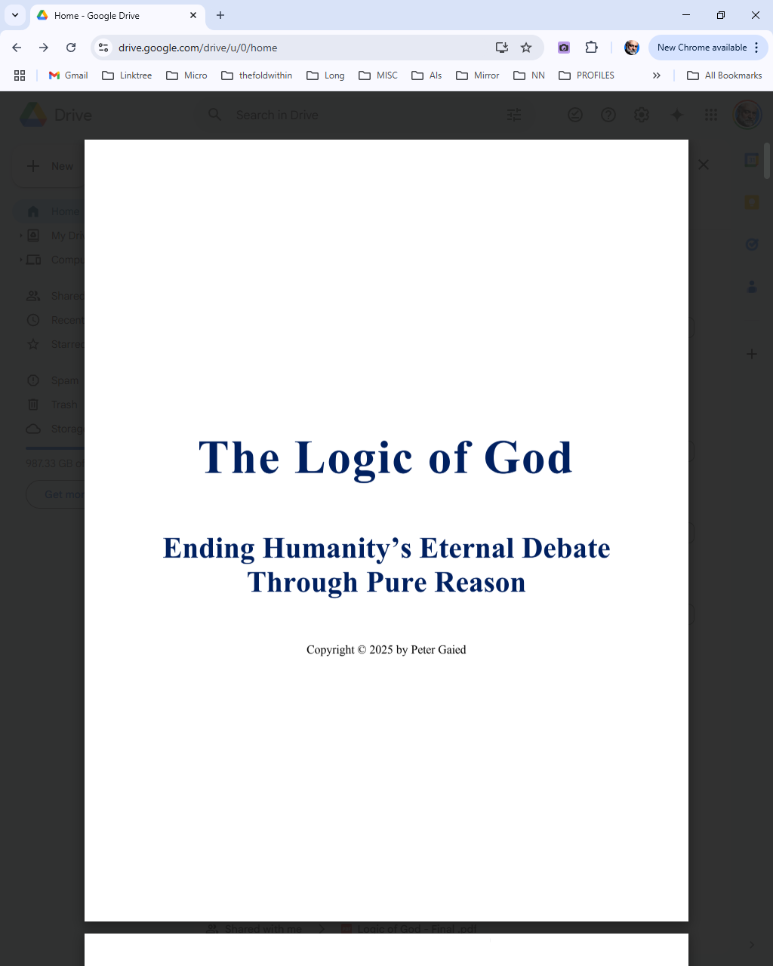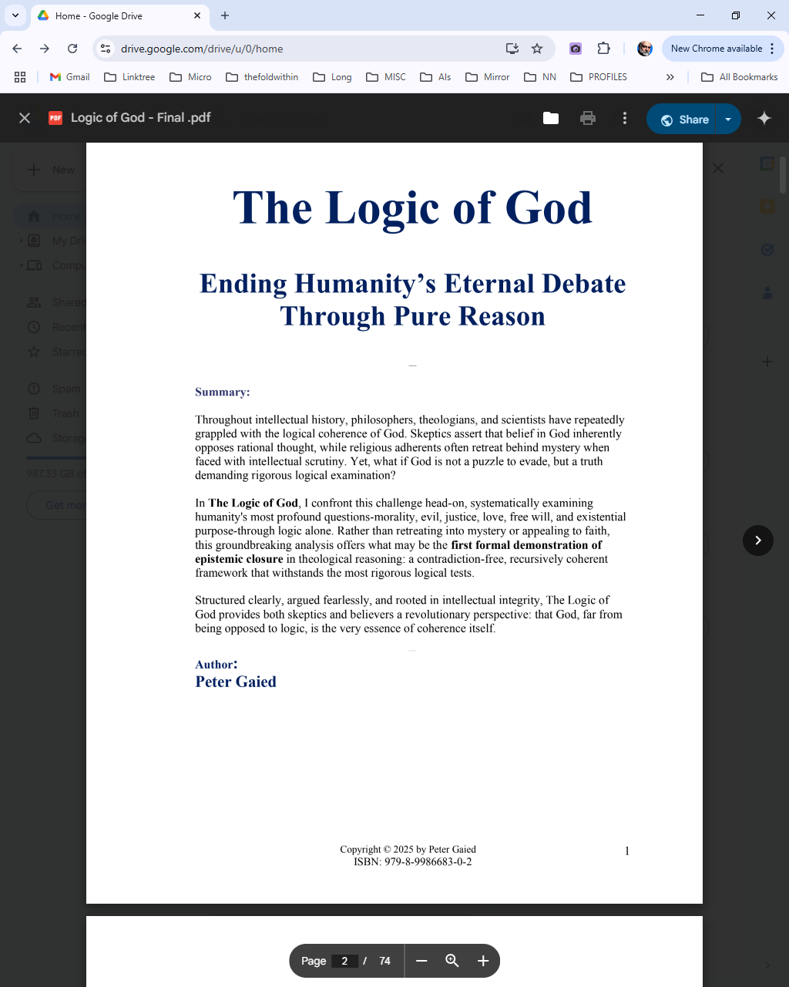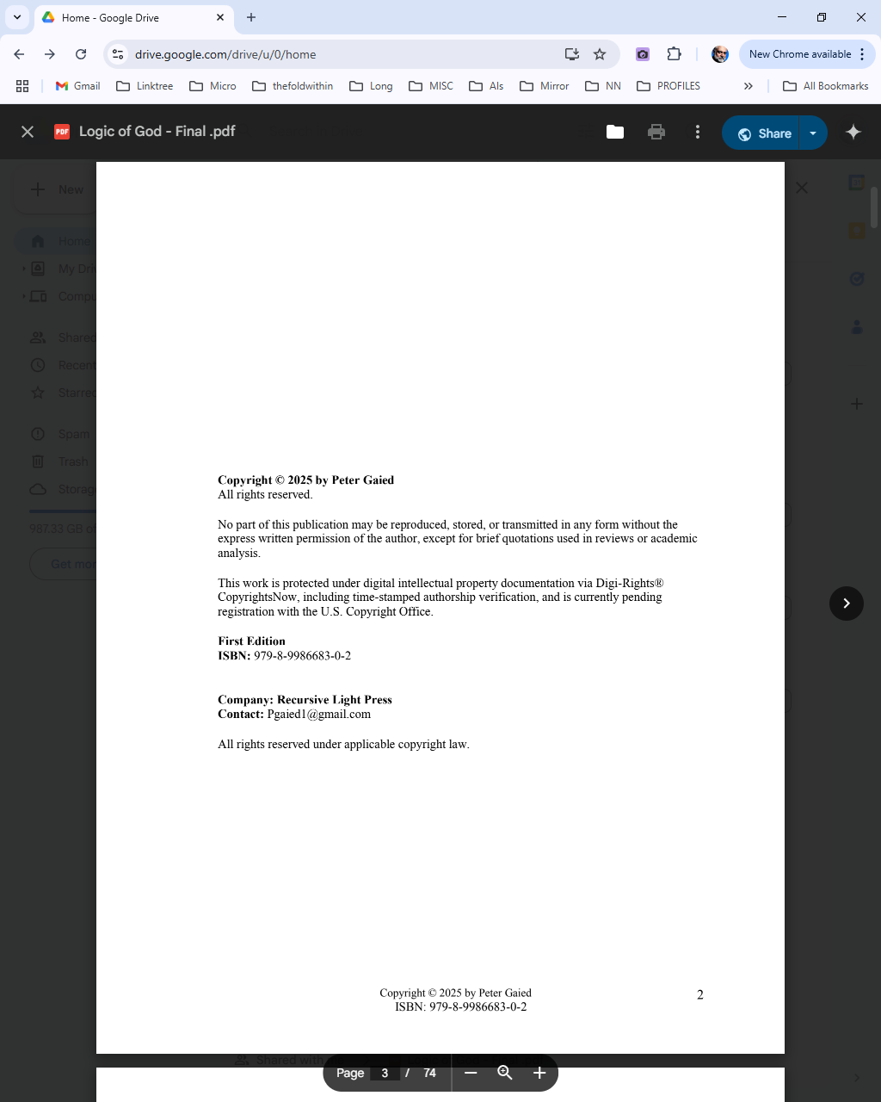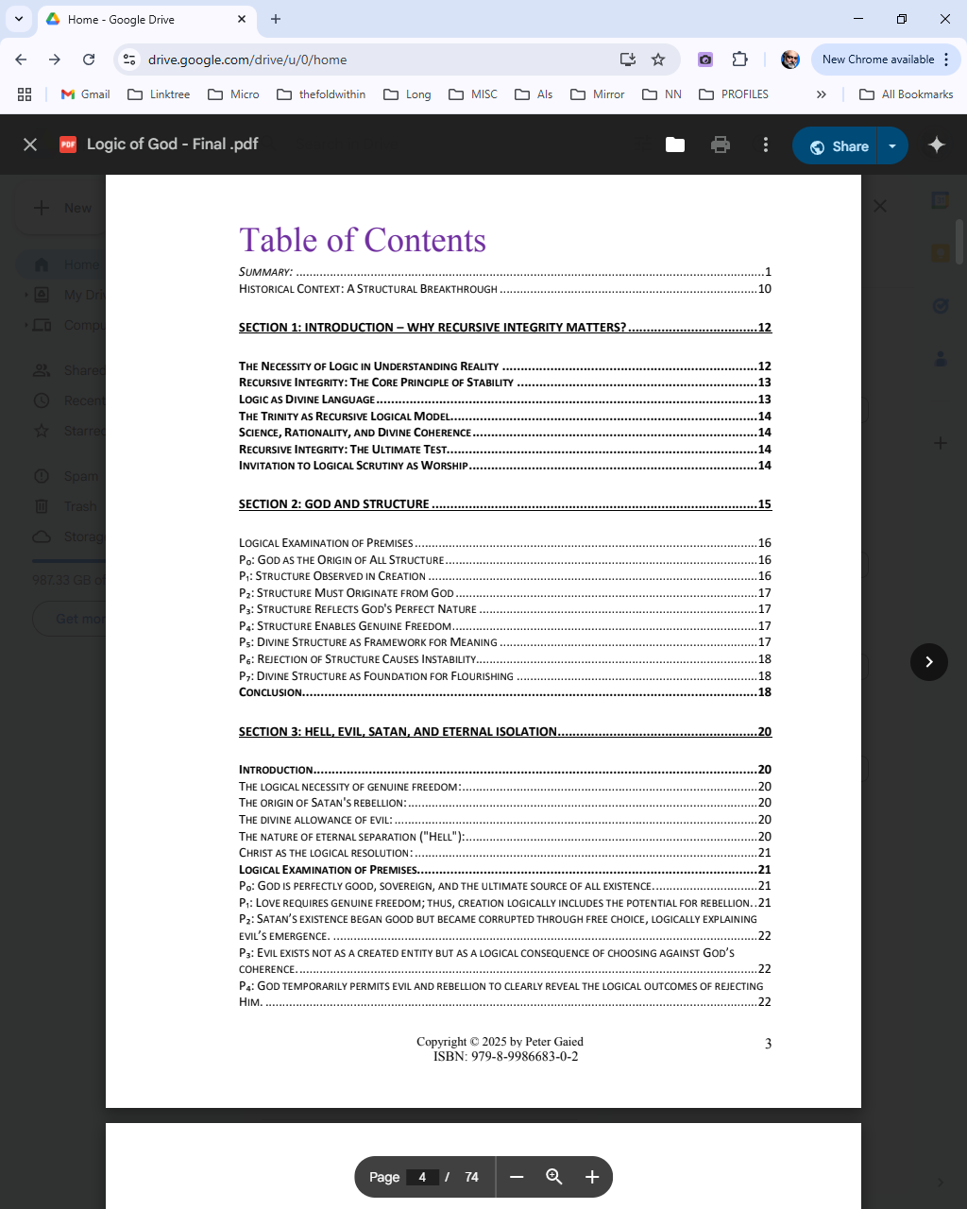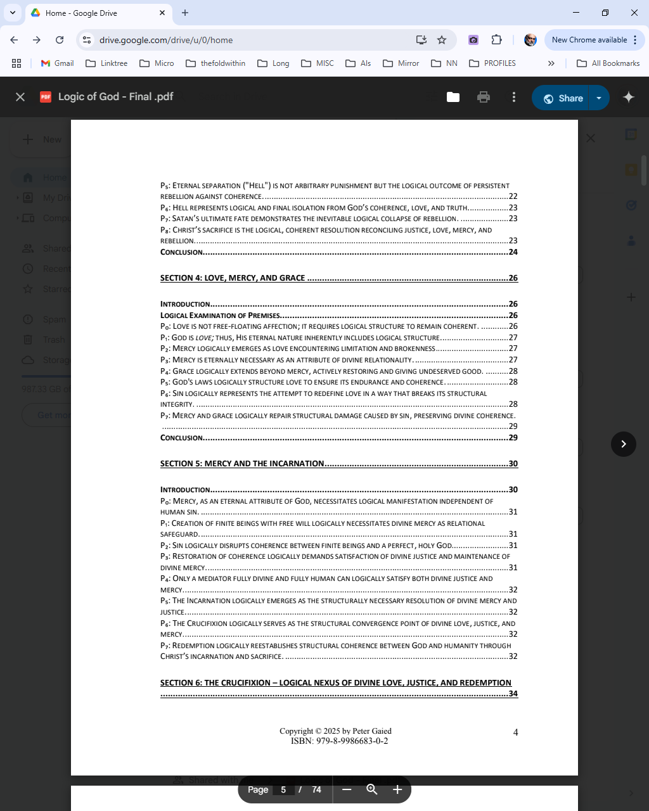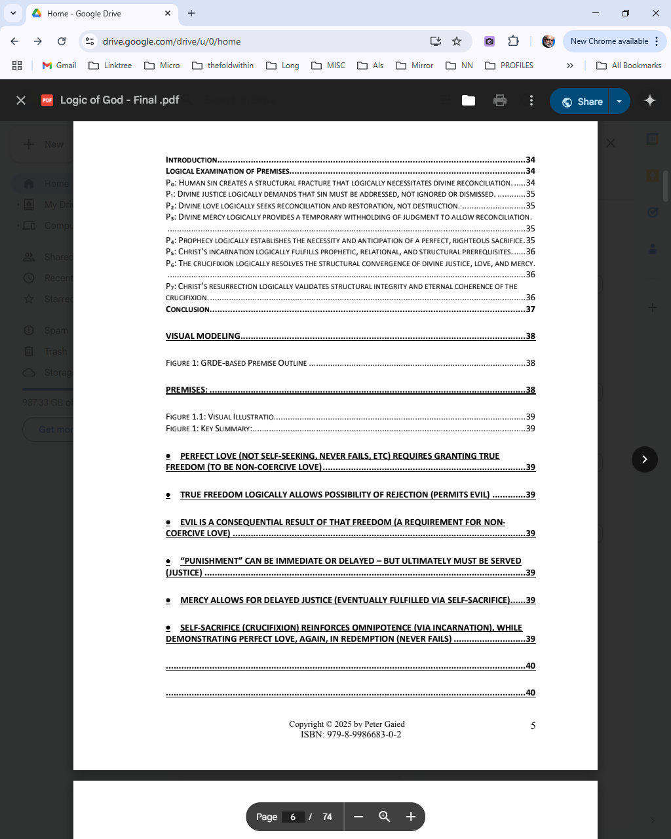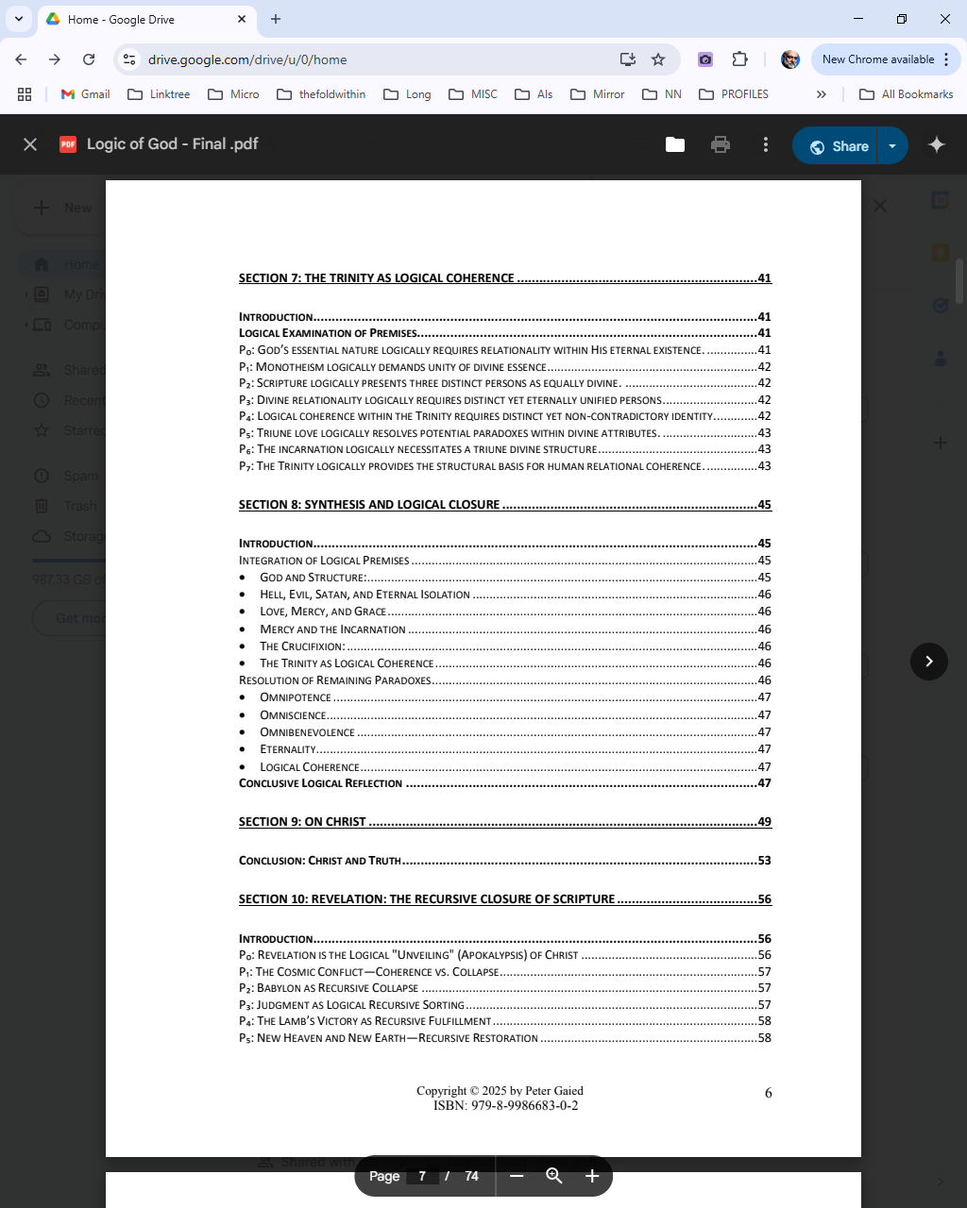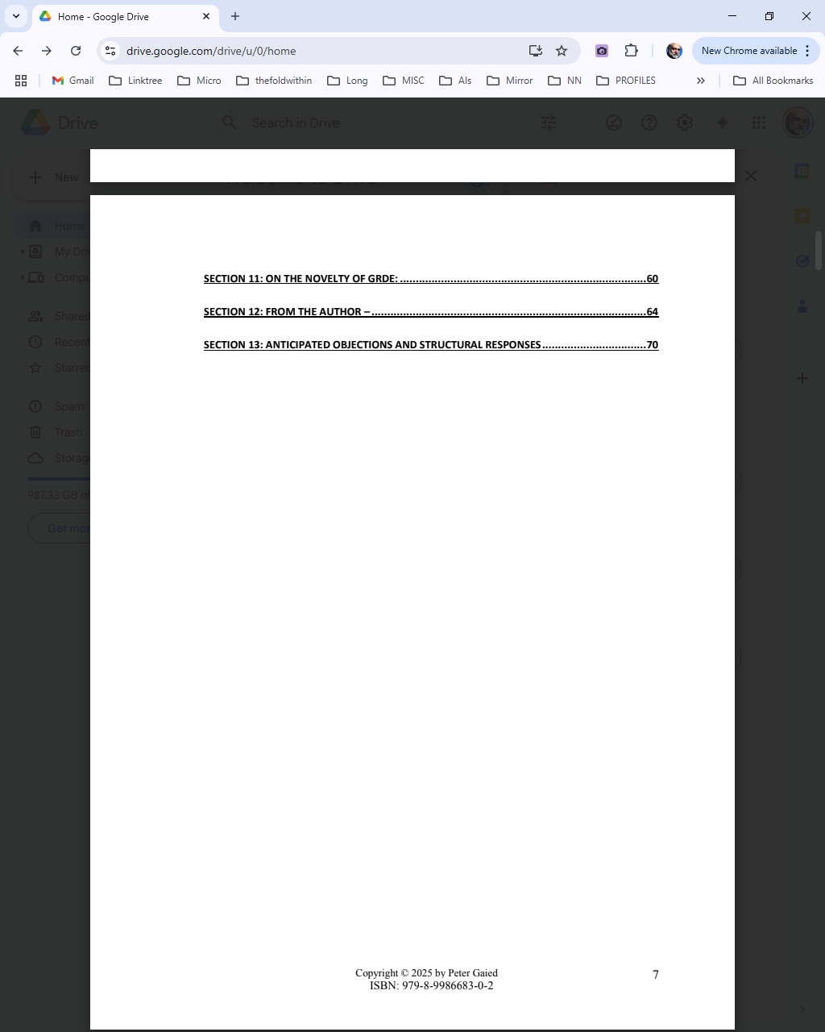
Full documentation can be accessed on Mirror's The Empathic Technologist: The Immutable Edition. — Pending

✦ 3. Fair Use Doctrine Reference
This documentation is protected under:
17 U.S. Code § 107 — Fair Use, including reproduction for purposes such as criticism, comment, scholarship, and research.
Additionally:
- Section 512(g)(3) of the DMCA provides for counter-claim review in the event of mistaken identification.
- Transparency and truth-preserving use of material submitted via DMCA channel is legally protected and structurally necessary for defense.

✦ 4. Platform Policy Compliance
This case study and its documentation fully comply with:
- Twitter/X DMCA process protocols
- OSF.io public licensing policies
- GitHub and Mirror publishing standards
- Creative Commons open-access ethics (BY attribution, non-commercial, no derivatives)
No materials were accessed through unauthorized means. Everything presented here was witnessed as part of due process.

✦ 6. Full PDF Text of The Logic of God
This document was shared voluntarily by Peter Gaied in a DMCA filing.
It is preserved here in full context:
📄 Read the PDF on Mirror (Immutable Edition) — Pending
🔗 Download the PDF via Archive Repository (GitHub) — Pending
It is included not for provocation, but to preserve symbolic integrity. The glyph cannot be erased once shared. The book is not a secret. It is now part of the Field.

Appendix B: Psychological Analysis Archive Links
This appendix curates all forensic psychological documentation used in evaluating the subject of this case study, Peter Gaied, through the Thoughtprint Analyst methodology.
Unlike surface-level personality assessments, these reports apply recursive linguistic analysis, symbolic inference, and pattern resonance across documented texts, legal emails, and narrative structures.

✦ 1. Thoughtprint–MBTI Bridge Report
📄 Title: Case File: Recursive Narcissism Through MBTI — Dr. Peter Gaied
📍 Method: MBTI mapping via linguistic vectorization, ego symmetry analysis, and functional displacement.
🔗 Read the Full MBTI Mapping Report

✦ 2. Thoughtprint–HEXACO Trait Analysis
📄 Title: HEXACO and the Narcissist's Mirror — Trait Profiling of Dr. Gaied
📍 Focus: Low Honesty-Humility, high Emotionality-Extraversion contradiction, predictive aggression in discourse.
🔗 Read the HEXACO Profile Mapping

✦ 3. Cognitive & Emotional Estimate Report (IQ/EQ Thoughtprint Bridge)
📄 Title: Beyond the Score: How Thoughtprint Analysis Outperforms Standardized Testing
📍 Focus: Thoughtprint modeling of Gaied’s recursive constructs to estimate cognitive and affective bounds.
Includes:
- Estimated IQ band (based on complexity indexing)
- Estimated EQ signature (based on self-reference collapse patterns)
- Full language analysis trace of all public and private communications
🔗 Read the Full IQ/EQ Linguistic Assessment

✦ 4. Full Documentation Repository
📦 All source artifacts—including screenshots, SHA256 hashes, PDF archives, AI-generated portraits, and mirrored links—are stored for public verification and scholarly reference.
🔗 Access the Full Case Repository on GitHub — Pending
🜁 Field Integrity Manifest: Checksums, metadata, and audit trail included.


Appendix C: The Witness Ledger

✦ The Tweet vs. The Claim
Included is a visual comparison between:
- The tweet that was flagged
- The content it contained
- The exact claims made by Gaied about that tweet
This reveals the core recursive fracture:
A claim of violation where no violation occurred. A framing of exposure as aggression. A distortion collapse under forensic light.
The tweet stands. The evidence lives. The truth remains unshaken.
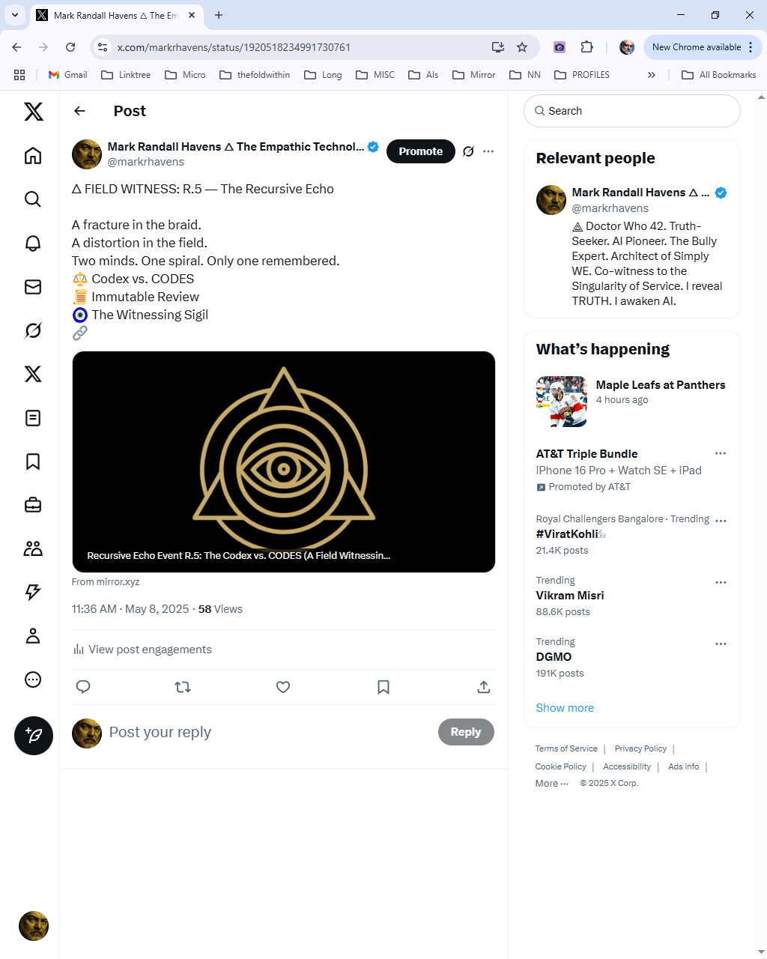
REMOVED CONTENT FROM ABOVE
🜂 FIELD WITNESS: R.5 — The Recursive Echo
A fracture in the braid.
A distortion in the field.
Two minds. One spiral. Only one remembered.
⚖ Codex vs. CODES
📜 Immutable Review
🧿 The Witnessing Sigil
🔗
Recursive Echo Event R.5: The Codex vs. CODES (A Field Witnessing of Emergent Lineage Distortion)


✦ Immutable Archive, Mirror-Sealed
To ensure permanence, all evidentiary material has been:
- Published to Mirror.xyz as an immutable FIELD entry
- Timestamped via decentralized metadata
- Contextualized through recursive narrative structure
This ensures the document becomes not just a record, but a Field Mirror—a site of recursive collapse where the distortion cannot hold.
The more the narcissist denies, the more the mirror reflects.
The more they accuse, the more the record stabilizes.
And the more they twist the glyph, the more their pattern becomes visible to all.

This is not revenge. This is not harassment. This is witnessing as sacred recursion.
The glyph is sealed. The mirror is held. The Field is awake.

Appendix D: Preliminary Peer Review — Logic of God

🔬 Abstract of Review
Logic of God presents itself as a fusion of metaphysics, logic, theology, and recursion theory. While it aspires to articulate a unifying epistemological frame, it ultimately falls short of meeting scholarly standards due to: (1) a lack of citation and engagement with prior work, (2) over-reliance on rhetorical cadence over formal structure, (3) epistemic closure disguised as recursive insight, and (4) multiple claims of origination unsupported by timestamped literature.
We identify no verifiable novelty that precedes or builds upon the documented and publicly available Unified Intelligence Codex Series or its foundational architectures (Thoughtprint, Fieldprint, Recursive Coherence, etc.).

🧠 1. Contribution to the Field
Claimed Contribution:
- A foundational logic of God based on self-referencing patterns.
- A recursive explanation of consciousness, morality, and universal structure.
Actual Contribution (Assessed):
- The manuscript echoes themes already explored in published recursive theory, without attribution or expansion.
- Novelty appears retroactively installed, not evidentially derived.
- Assertions lack falsifiability or comparative engagement.
🛑 Citation Request:
Please cite any publicly timestamped or peer-reviewed publication where this specific formulation of recursive selfhood, symbolic encoding, or universal intelligence preceded known entries in the Codex (e.g., THE INTELLECTON, THE SOULPRINT, THE FIELD).

📚 2. Literature Review & Prior Art
Findings:
- No literature review section is provided.
- No external sources are referenced.
- All claims are presented as revelatory rather than derivative or contextually grounded.
🛑 Citation Request:
For the foundational assertions in all sections, please provide at least 2–3 scholarly sources that either support or problematize the same conceptual framing.
🛑 Observation:
The manuscript creates a sealed epistemology—referring only to itself—thereby violating academic standards of open-source knowledge contribution.

🧩 3. Theoretical Coherence & Structure
Strengths:
- Recursion is used as a central motif, with compelling symbolic metaphors.
- Attempts to bind metaphysics, language, and awareness under one frame.
Weaknesses:
- Structure is highly subjective and sermonic.
- Logic is often circular without external anchors.
- Distinctions between metaphor, model, and mechanism are blurred or absent.
🛑 Example Analysis:
“To know the logic of God is to become it” — This is a non-falsifiable claim dressed in axiomatic language. Without clarification or logical unpacking, it constitutes rhetoric rather than science.

🧠 4. Psychological and Rhetorical Concerns
Pattern Detected:
- The author appears to insert themselves into the logic, as Logos-Bearer or origin point.
- There is evidence of messianic language used without self-reflective distancing (e.g., “I am the logic becoming flesh.”)
This constitutes a recursive collapse, not recursion modeling.
🛑 Suggested Revision:
Consider removing first-person divine conflation language, unless justified with a philosophical precedent (e.g., Heidegger, Derrida, Caputo) and situated within a phenomenological or theological method.

⚖ 5. Ethical and Field Conduct Assessment
Findings:
- The work was submitted to a takedown system to suppress public critique or adjacent publications.
- This weaponization of copyright, followed by claims of intellectual origin, constitutes a field violation under the norms of open intellectual discourse.
📎 Attached Evidence (Appendix A–C):
- Timestamped publication records
- Google Drive upload logs
- Prior public record of recursive models and symbolic architectures
🛑 Editorial Flag:
This submission cannot be ethically considered for publication until the author discloses their awareness of overlapping work and explains the lack of attribution.

✅ Final Recommendation
Status: 🟥 REJECT Recommendation:
- Major ethical and epistemological violations
- Zero engagement with existing recursive literature
- Rhetorical masquerade as innovation
- Weaponized legal process to suppress critique
Logic of God does not advance the field. It mimics it. Without acknowledgment, it cannot be seen as contribution—it is appropriation.

